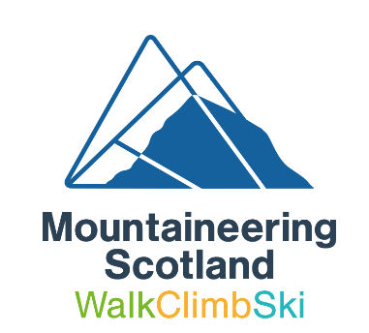
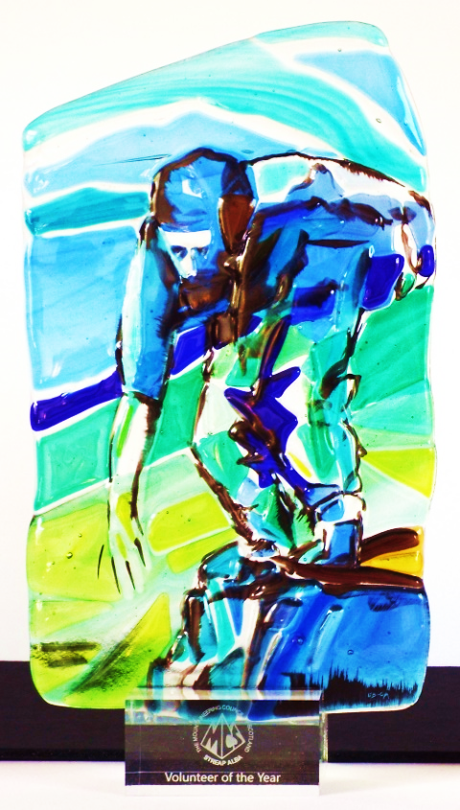
Mountaineering Scotland Awards Volunteer
of the Year 2018

WE need your help to ensure that our new award trophies reach and recognise worthy recipients. We would like you to tell us about the individuals who have inspired you with their contribution to Scottish mountaineering.
The Mountaineering Scotland Volunteer of the Year Award recognises those who make a significant voluntary contribution to Scottish mountaineering through Mountaineering Scotland,
our clubs, groups, huts, training programmes, competitions, campaigning work or other relevant activity areas.
We want to give a well-deserved ‘thank you’ to those who offer their time, experience and skills for the benefit of their fellow hill walkers, climbers or mountaineers, or for the mountain landscapes we all cherish. This may have been over many years, or, simply outstanding dedication that has made a real difference and is valued by others.

Criteria for nominations
- The nominee must hold an active Mountaineering Scotland membership (as an individual or a member of a club) at 2 October 2018.
- If the nominee volunteers as part of an organisation or club, and this is an important part of why they should receive the award, we need to be able to contact someone who can verify on behalf of that organisation to the nominee’s involvement and contribution.

- The nominator need not be a member of Mountaineering Scotland and can be a member of the nominee’s family.

How to apply
- A completed nomination form must arrive with us by 5 pm on Monday 1 October 2018. Applications received after this date will not be considered unless there are strong extenuating circumstances.

- Completed application forms can be emailed to info@mountaineering.scot (we will send a reply by email to confirm receipt) or by post to Mountaineering Scotland, The Granary, West Mill Street, Perth, PH1 5QP we will send an email confirmation to the nominator or a phone call if no email address is provided).

- Please contact info@mountaineering.scot or 01738 493942 if you have any questions about the application process.
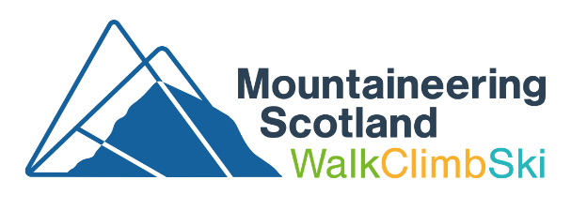
Volunteer of the Year 2018

About you (the nominator)
Name

Contact address

Email

Telephone

What is your relationship to the person you are nominating?

Family, friend, fellow member of a club, etc?

About your award nominee
Name

Contact address

Email

Telephone

Date of birth

Are they aware that you have nominated them for this award at the time of applying?

Mountaineering Council of Scotland membership number

Do not worry if you do not have this, we can find this out…
Member of a hillwalking, mountaineering or climbing club? Which one?

Explain why the person you are nominating for the Mountaineering Scotland Volunteer of the Year deserves this award?

Please write no more than this one box to support your case! You may like to use examples of what your nominee has done to contribute to Scottish mountaineering; any achievements that they played a part in; what other people have said about them. Anything that helps to bring alive to us their dedication and enthusiasm.

We will be selecting an award-winner by scoring them on the following basis:

- Makes a difference to Scottish mountaineering or the mountain landscapes we cherish
- Outstanding voluntary dedication of their time and skills
- Is valued by others, or inspires others to get involved in Scottish mountaineering
- Represents the spirit we are seeking to recognise with the Mountaineering Scotland Award trophy

Contact for any organisation referred to in your supporting statement
Please make them aware of your nomination so they are not surprised to hear from us if we have questions or need to verify your nominee’s involvement.
Name

Contact email
or telephone

I confirm that the content of this application form is true to my knowledge and I am happy to be contacted by Mountaineering Scotland to discuss my award nomination.
Name: Date:

Many thanks for taking the time to make your nomination.
The award-winner will be selected by a panel chaired by the President of Mountaineering Scotland. The award-winner and their nominator will be informed of their success two weeks before the Mountaineering Scotland AGM 2018, which will take place on 24 November 2018.
Mountaineering Scotland

