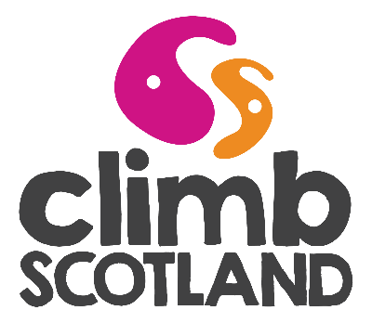
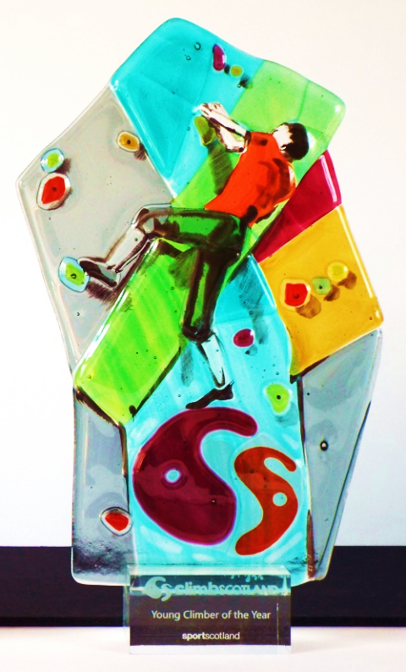
ClimbScotland Award
Young Climber
of the Year 2018

WE need your help to ensure that our new award trophies reach and recognise worthy recipients. We would like you to tell us about the individuals who have inspired you with their contribution to Scottish mountaineering.
The ClimbScotland Young Climber of the Year Award recognises participation and personal achievement among our younger members (under 25s) in climbing, one of Scotland’s fastest growing sports.
We are looking for a young person whose talent, enthusiasm and commitment to climbing inspires other young people to start or progress with their own climbing. This might be through competition climbing, coaching, club activities or other exciting endeavours.

Criteria for nominations
- The nominee must be under 25 years old and hold an active Mountaineering Scotland membership (as an individual or a member of a club) at 2 October 2018.
- If the nominee volunteers as part of an organisation or club, and this is an important part of why they should receive the award, we need to be able to contact someone who can verify on behalf of that organisation to the nominee’s involvement and contribution.

- The nominator need not be a member of Mountaineering Scotland and can be a member of the nominee’s family.

How to apply
- A completed nomination form must arrive with us by 5pm on Monday 1 October 2018.
Applications received after this date will not be considered unless there are strong extenuating circumstances.

- Completed application forms can be emailed to info@mountaineering.scot (we will send a reply by email to confirm receipt) or by post to Mountaineering Scotland, The Granary, West Mill Street, Perth, PH1 5QP (we will send an email confirmation to the nominator or a phone call if no email address is provided).

- Please contact info@mountaineering.scot or 01738 493942 if you have any questions about the application process.

Young Climber of the Year 2018
About you (the nominator)
Name

Contact address

Email

Telephone

What is your relationship to the person you are nominating?

Family, friend, fellow member of a club, etc?

About your award nominee
Name

Contact address

Email

Telephone

Date of birth

Are they aware that you have nominated them for this award at the time of applying?

Mountaineering Scotland
membership number

Do not worry if you do not have this, we can find this out…
Member of a hillwalking, mountaineering or climbing club? Which one?

Explain why the person you are nominating for the ClimbScotland Young Climber of the Year deserves this award?

Please write no more than this one box to support your case! You may like to use examples of what your nominee has done to contribute to Scottish youth climbing; any achievements that they played a part in; what other people have said about them. Anything that helps to bring alive to us their dedication and enthusiasm.

We will be selecting an award-winner by scoring them on the following basis:

- Enthusiasm and commitment to climbing
- Climbing talent and personal achievement
- Inspires other young people to get climbing
- Represents the spirit we are seeking to recognise with the ClimbScotland Award

Contact for any organisation referred to in your supporting statement
Please make them aware of your nomination so they are not surprised to hear from us if we have questions or need to verify your nominee’s involvement.
Name

Contact email
or telephone

I confirm that the content of this application form is true to my knowledge and I am happy to be contacted by the Mountaineering Scotland to discuss my award nomination.
Name: Date:

Many thanks for taking the time to make your nomination.
The award-winner will be selected by a panel chaired by the President of Mountaineering Scotland. The award-winner and their nominator will be informed of their success two weeks before the Mountaineering Scotland AGM, on Saturday 24 November 2018, where the award will be presented.
Mountaineering Scotland

